Ortiz Guzman, Julio

8 November, 2021

ECe 3200-01 Lab 11

The Push-Pull Amplifier

**Objective:**

The objective of this lab is to construct a dual-supply push-pull amplifier and make compensation to reduce the cross-over distortion. Student will also measure the performance parameters of the circuit and compare versus the predicted ones.

**Prelab:**

1. For the circuit shown in fig.1a determine the power efficiency, η, when the input voltage is set to, vi = 20 Vpp at 1 kHz. At such a large signal amplitude you may ignore the 0.7 V drop across the base-to-emitter junctions. The power delivered by **each** power supply may be calculated from PS+ or - = IC (avg.) xVcc where IC (avg.) = IC(pk) / π and IC(pk) = vo(pk) / RL . Notice that vo(pk) = vi(pk) –0.7 V or vo(pk) ≈ vi(pk) under the assumption that 0.7 V may be ignored. The output power PO = vo(rms)2 / RL and the total absorbed power from both power supplies is equal to PS = PS+ + PS-. Also calculate the input resistance Rin from Rin = vi / iin. For both transistors assume β = 100Draw the small signal equivalent circuit of the CASCODE stage using hybrid-π models. Determine the mid-band frequency voltage gain of the CE stage defined as Av1 = vo1 / vi. Also calculate the gain of the CB stage, Av2 = vo / vi2. Determine the input impedance, Rin1 = vi / iin, of the CE amplifier. Also determine the input impedance Rin2 of the CB stage. It will help if the CB stage is presented as an amplifier with an input impedance of Rin2 ≈ 1/ gm and a dependent output current source of gm vi2.

η = 78.7 % , Rin = 70 kΩ

1. The circuit of fig.2 utilizes two silicon diodes to compensate for the VBE offset of each transistor. The biasing resistors R1 will set the diode current so that approximately each diode will compensate for 0.6 V of the opposite transistor VBE.

Determine R1 so that the diode current will be about, ID1or2 = 1 mA.

R1 = 9.4 kΩ , R*1=10 kΩ

1. The circuit of fig.3 also compensates for the base-to-base voltage drop of the two output transistors Q1 and Q2. But the circuit has the advantage of providing an adjustable offset voltage by tuning the wiper (the movable contact shown as arrow) of the potentiometer. Here R2 and R3 are the portions of the resistance in each arm of the potentiometer; the total resistance of the potentiometer is, R2 + R3 = 1 kΩ.

Determine R1, R2, and R3 so that IR1 = 2 mA and VCE3 = 1.2 V assuming VBE3 = 0.7 V and β = 100 for all transistors. You may ignore the base currents of Q1 and Q2 compared with IC3.

R1 = 9.4 kΩ , R2 = 585 Ω R3 = 415 Ω

**Procedure:**

1. **Basic Class-B**

**Measuring η** – Construct the circuit of fig.1(a) and set the input vi to 20 Vpp at 1 kHz and the power supply voltages to +/-10 V. Set the Ammeters on DC mode and place them in the collector path of Q1 and Q2. The Ammeters will measure the average collector current of each transistor which is identical to the current delivered by the individual power supply. Calculate the total supplied average power, PS, from

PS = IC1(Avg.) . VCC+ + IC2(Avg.) . VCC- .

IC1(Avg) = 8.57 mA , IC2(Avg) = 8.58 mA, PS+ = 8.57 x 10 v = 85.7 mW,

PS-  = 8.58 x 10 v = 85.8 mW

PS = PS+ + PS- = 171.5 mW

Now measure vo(rms) with the oscilloscope utilizing the rms option in the measurement menu and compute PO, then calculate the measured power efficiency, η, from

η = ( PO / PS) x 100 %

vo(rms) = 6.4 Vrms , PO = vo(rms)2 / RL = 124 mW , η = 72.3 %(meas.)

Compare the measured η versus the one calculated earlier in part 1 of the prelab.

**Measuring Rin** –Now introduce the resistance Rg between the signal generator and amplifier input (see fig.1(b)). Set the **signal generator** amplitude to vg = 20 Vpp and measure vi. Calculate Rin from the measurements and compare to part 1 of the prelab.

vi = 17.5 Vpp , iin = (vg – vi ) / Rg = 0.25 mApp , Rin = vi / iin = 70 kΩ

**Measuring DC Values** – With the signal generator amplitude reduced to near zero measure the following DC values:

VB1 = 0 V , VB2 = 0 V , VE1,2 = 0 V , IC1= 0 mA , IC2 = 0 mA

**Documenting Distortion-** Restore the circuit to fig.1(a)and document the vo(t) and vi(t) waveforms for values of vi = 3 Vpp and 7 Vpp at 1kHz. Attach the two pictures to your report. Notice that the crossover distortion is significant at smaller amplitudes.

1. **Reducing Distortion with Diodes**

**Checking DC Bias**-Construct the circuit of fig.2 with the value of R1 you calculated in the prelab part 2. Make sure both resistors labeled as R1 have nearly identical values. With signal generator off, measure the following DC quantities.

VB1 = 0.629 V , VB2 = -0.592 V , VE1 or 2 = 11 mV , IC1= 0.19 mA , IC2 = 0.16 mA,

If IC1 ≠ IC2 explain why in your report. If VE1,2 ≠ 0 , explain why. Ideally the collector current of both transistors should be identical and equal to 1 mA.

**Checking Distortion**- Set vi once to vi = 3 Vpp and next to 7 Vpp at 1kHz and document the input/output waveforms. Distortion at the output should be less compared with the original class-B amplifier. Attach the pictures to your report.

**WARNING:**

BEFORE BEGINNING PART 3 MAKE SURE BOTH POWER SUPPLIES ARE OFF. FAILUER TO DO SO MAY OVERHEAT AND DISTROY YOUR MATCHED TRANSISTORS BEFORE PROPER ADJUSTMENT, ENDING THE PART 3 INCOMPLETE.

1. **Reducing Distortion with An Adjustable Compensator**

With the power supplies **off** construct the circuit of fig.3 with the calculated value of R1 in the part 3 of the prelab (make sure both R1s have identical values). The 1 kΩ potentiometer setting R2:R3 is not important at this point since it will be adjusted.

Step 1 – Set the initial value of the R2 in the potentiometer to ZERO Ohm. This can be verified by connecting an Ohm meter between the two points, the collector and base of the transistor Q3, and adjusting the wiper till the meter shows zero or a few Ohms.

Step 2 – Now turn ON the +/- 10 V power supplies. With the signal generator OFF measure the following DC values: With RE = 1 Ω instead of 10 Ω (See Q1,2).

VB1 = 0.361 V , VB2 = -0.312 V, VE1,2 = 0 V , 0 V , IC1= 0 mA , IC2 = 0 mA ,

You may see IC1&2 are nearly zero because VCE3 is now equal to VCE3 = 0.7 V and hence VBE1 = VBE2 = 0.35 V. **Keep the Ammeters engaged in the circuit and monitor IC1&2**.

Step 3 – Now slowly increase (follow an adjust-wait-read strategy) R2 till IC1 and IC2

Q- point currents are built to no more than 1 mA. The Q-point is now set.

NOTE – In a professional circuit all **three** transistors are kept at the same temperature by mounting them in the same vicinity on a common heat-sink. As it is important for these three transistors to stay at the same temperature in order to have a common values for VBE, β and IS at all temperatures.

Measure the following DC values with the signal generator off:

VB1 = 0.679 V, VB2 = -0.641 V, VE1,2 = 25.3 mV, 5.1 mV, IC1= 0.98 mA, IC2 = 0.94 mA

**Checking Distortion-** Set vi once to vi = 3 Vpp and next to 7 Vpp at 1kHz and document the input/output waveforms. Compare this result with the one in part 2 of the procedure. If no improvement is noticed, you may readjust R2 to remove any apparent residual distortion. Do not over adjust R2 as it may cause overheating. Attach the pictures to your report. (See picture doc.)

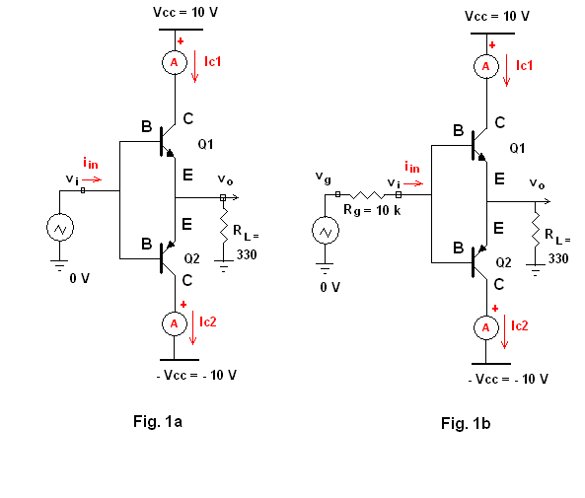

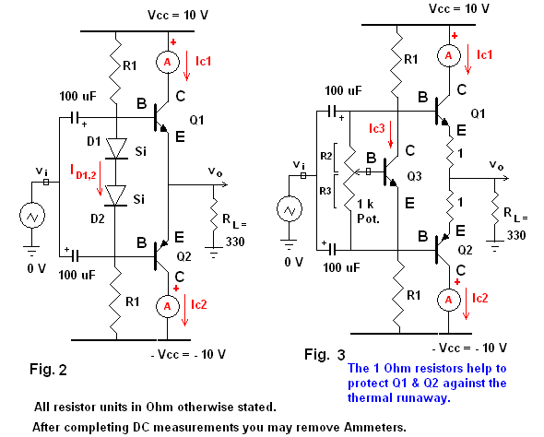

**Conclusion:**

As a result of this lab, I was able to better understand how to design a dual-supply push-pull amplifier circuit and create compensation to reduce the cross-over distortion. Although I was not able perform the lab physically, I was still able to visualize and understand the circuit with the help of pSpice, and the zoom meeting provided. As mentioned in the lab manual, class B-stage requires two complementary transistor pairs for operation. In this lab, we used two PNP (2N3904) and NPN (2N3906) transistors, which we gained familiarity with in previous labs. Class B amplifiers are significant as it allows each transistor to conduct only for 50% of the period cycle. More specifically, one device conducts for the first 50% of the cycle, usually producing a positive value, while the other transistor is in cut-off then the second device will take over and conduct for the next 50% of the cycle. The Q-point of each device is placed at the cut-off point found from the graph. However, a major problem with class-B amplifiers is the distortion found in the waveforms. This is due cross-over distortion which happens when conduction duty is transferred between the transistor pairs.